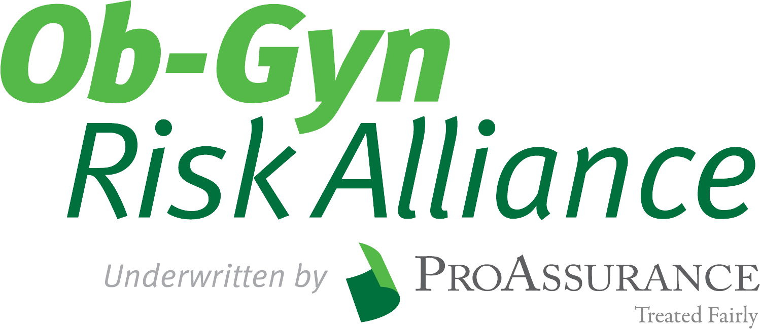
ProAssurance Casualty Company • PO Box 590009 • Birmingham, AL 35259-0009 • 800.282.6242 • Fax 205.868.4040
Completion of this supplemental application is required as a participant in the Ob-Gyn Risk Alliance program. Please be advised all information disclosed on this form is subject to the anti-fraud statement contained on your initial application.
Physician Name:
Are you currently a ProAssurance insured? Yes No Policy Number:
1. Physician Information
- List the hospitals where you have privileges. Note: These hospitals will be referenced in this section and the
“Hospital Information” section.
Hospital 1 Name: Percentage of your patients admitted into this facility: ________%
Location: Privileges: Active Pending
Hospital 2 Name: Percentage of your patients admitted into this facility: ________%
Location: Privileges: Active Pending
Hospital 3 Name: Percentage of your patients admitted into this facility: ________%
Location: Privileges: Active Pending
- Please provide the total number of deliveries that you have performed for the past year: ________________
Spontaneous vaginal deliveries – number per year:
Vaginal assisted deliveries – number per year:
C-sections – number per year:
VBAC – number per year:
Unattached (No-doc) deliveries – number per year:
Unattended deliveries – number per year:
- Does your hospital require you to remain in-house for VBAC patients?
Hospital 1: Yes No Hospital 2: Yes No Hospital 3: Yes No
- Do you allow patients to develop an alternative birthing plan? Yes No
If yes, please list examples (e.g., water births, limited or no antenatal screening, or no continuous,
invasive fetal monitoring):

  - Do your partners or any on-call physicians follow established alternative birthing plans? Yes No
If no, please explain:
- Have you completed a fetal monitoring course or update within the previous 24 months? Yes No
- Have you incorporated the National Institute for Child Health and Development’s (NICHD)
standardized nomenclature for fetal monitoring interpretation into your practice? Yes No
- Do you perform labor epidurals? Yes No
Do you have evidence of training and continuing education for labor epidurals? Yes No
- Do you supervise mid-level providers? Yes No
Indicate number: CRNA CNM CRNP
- Do you provide services or act as the medical director for any off-site delivery programs? Yes No
If yes, please list:

2. Gynecology
- Total number of annual gynecology surgery procedures:
- Total number of annual hospital/outpatient facility procedures:
- Have you been granted robotic assist surgery privileges? Yes No
- Do you perform any of the following office-based procedures or services? Yes No
If yes, please check services performed:
Colposcopy
Biopsy
LEEP
Cryosurgery
IUD
Non-invasive permeant birth control
Subdermal contraceptive therapy
Bio-identical hormone replacement therapy
Ablations
Urodynamic testing/treatment
Fertility treatment
Pain Management
Weight loss management
Other
- Do you provide any in office procedures requiring moderate sedation or anesthesia? Yes No
- Do you provide any in office or outpatient cosmetic procedures/services? Yes No
If yes, please check services performed:
Botox
Derma fillers
Laser hair removal
Laser skin resurfacing
Sclerotherapy
Microdermabrasion
Tumescent liposuction or liposuction
Breast augmentation
Breast reduction
Breast reconstruction

Applicant’s Signature: Date:

I agree that my office staff and I will comply with all Ob-Gyn Risk Alliance risk management programs administered by ProAssurance companies. Our compliance includes cooperating
with ProAssurance and its employees and independent contractors in all risk management assessments and recommendations, participating in educational programming, and committing
to work with the Ob-Gyn Risk Alliance to improve patient care and thus reduce losses.
I agree to ensure that my staff will work to further such risk management collaboration and
comply with all educational and risk management improvement recommendations.
I understand that compliance with this statement is necessary for membership in the Ob-Gyn
Risk Alliance Purchasing Group, and failure to comply may jeopardize further participation in
the program.

Applicant’s Signature:
Date:

